CMSC 204
Huffman Lab

- Create a Huffman Tree and generate the codes for each character of the following input:
create a huffman tree
For consistency:
- If same frequency – put in priority queue alphabetically; put space before other characters of the same frequency
- Add subtrees to end of group with same priority
- Lower number has higher priority (goes to front)

Char Freq Code
r 2 000
t 2 001
c 1 0100
h 1 0101
m 1 0110
n 1 0111
3 100
a 3 101
u 1 1100
f 2 1101
e 4 111

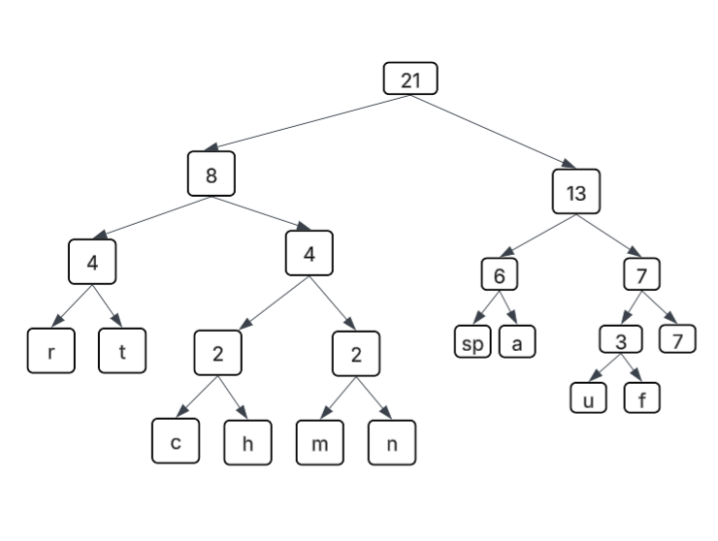

Now encode “create a huffman tree”
ANS: 01000001111010011111001011000101110011011101101010111100001000111111

- Based on the following Huffman tree and binary sequence, what is the text

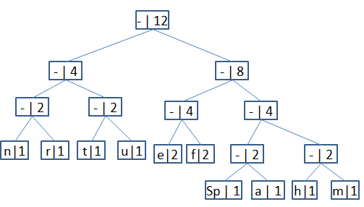

1110011101101111111010001100010001100100

Ans: huffman tree

